RUSSIA

It took many years for Russia to grow and develop as a country. This development essentially started when the Principality of Muscovy began to conquer and absorb surrounding principalities. In the 17th century, the Romanov Dynasty continued this expansion. Eventually, under the rule of Peter the 1st, the conquered land mass was extended to the Baltic Sea and the whole territory was renamed the Russian Empire. More territories were conquered during the 19th century and then later, in 1917, the imperial household was overthrown. Communism took a hold of the country, many lives were lost and the economy slowly fell into a decline. In December 1991, the USSR was splintered into fifteen independent republics and it has since struggled to build a good democratic political system. The country is starting to regain economic momentum and many of the scars left by communism are slowly disappearing. Unfortunately, there is still guerrilla conflict in Chechnya. Winston Churchill famously, called Russia "a riddle, wrapped in a mystery, inside an enigma", and in doing so he was merely following a centuries-old belief that Russia was so odd and eccentric that all attempts to understand it were impossible.

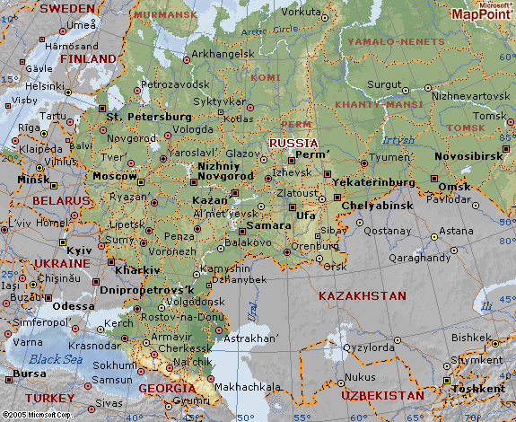

Location
Russia is an incredibly large country and it expands over much of Eurasia. Much of Northern Asia and some of Western Europe are part of this country and it is bordered by the Arctic Ocean and the North Pacific Ocean. It shares its' borders with many countries. The geographical coordinates for Russia are 60 00 N, 100 00 E. Moscow is the capital city.

Geographical Area
The geographical area that makes up Russia spans 17 075 200 square kilometers. Of this, 16 995 800 square kilometers is land and 79 400 square kilometers is water. It also has 37 653 km of coastline. Russia is the biggest country in the world.

Climate
The climate in Russia is rather varied due to the different geographical regions in the area. Generally speaking, the winters vary from cool to frigid while the summers range from humid to cool. The further north one gets the cooler the climate will be. Siberia is a sub arctic regions and the polar north of Siberia is tundra.
In general, the best time to visit is May-September, when the day temperatures are in the /23-35 C, and nights are in the 10-23 C. Spring and early fall, however, are unpredictable: Snow flurries and temperatures in the mid /-5 C are possible in May and September. Be sure to take waterproof shoes for spring or fall visits - there's a lot of mud. There are a few reasons someone might want to go during the winter: In Moscow and St. Petersburg, the leaves have fallen and the striking architecture can be seen much more clearly; it's also easier to get tickets to see the Bolshoi and Kirov (Mariinsky) ballets and operas, and there are no crowds at other tourist attractions. Those visiting in winter will want to take along their warmest clothes, boots and hats: It's bitterly cold (Moscow is as far north as southern Alaska) and quite dry. We recommend a long, insulated coat - the best you can afford.

VISA The visa is to be obtained prior to arrival in the country

From  St Petersburg | Kilometres | Miles
Moscow | 713 | 446
Pushkin | 35 | 22
Peterhof | 30 | 19
Lomonosov | 39 | 24
Novgorod | 189 | 118
Kolpino | 33 | 21
Vyborg | 142 | 89
Kronshtadt | 50 | 31
Murmansk | 1345 | 840
Tallinn (Estonia) | 357 | 223
Helsinki (Finland) | 390 | 244

CURRENCY:
The official Russian currency is the Russian ruble. The currency code for the ruble is RUR. The ruble has a comparatively low value against other currencies.
Getting There
Air : Russia’s chief international carrier remains Aeroflot. Most international flights fly into both Moscow and St.Petersburg. Flights from BOM to Moscow by Aeroflot and Air India(SU)
Train: Rail travel into and around Russia is romantic and often comfortable,
but time-consuming. The network of railways in Russia probably provides the most extensive form of transportation throughout the country. The Railway system was started with the building of the Trans-Siberian railway many years ago and it has since gone from strength to strength. In more recent years, a metro system is being properly established. Transport by train is cheap and reliable and you can usually find a train that will take you to where you want to go.
Ferry: St. Petersburg, one-time capital of imperial Russia and the second-largest city in Russia, is the country’s largest port. It’s also become a popular cruise-ship destination. Some places in Russia can be better reached by crossing the icy waters of this vast continent. There are quite a few ferry services but boats are mostly used to explore the polar regions above Russia where there are a few wildlife reserves. There are also a few pleasure cruises on offer
Bus: By bus, the Helsinki-to-St. Petersburg journey takes about 7 hours and is often included onScandinavian-based tours. You can hire cars in Russia to use for the duration of your trip. There is a good highway system to accommodate the growing usage of motor vehicles in the country. There are also quite a few jeep tours available for the more adventurous.

TIME:
Russia has Time zone: GMT/UTC +2, +3, +4, +5, +8, +10 and +12 ()

Regions in Brief
Russia is a huge country, stretching from the borders with Estonia, Latvia, Belarus,
Ukraine and Turkey in the west, passing Kazakstan, Mongolia and China, to reach the Pacific Ocean some 6000km later.

CLOTHING:
Russia is a fiercely patriarchal society. "Old-fashioned chivalry" is expected by both sexes - including holding doors open for ladies (and expecting to have the door held for you), helping on/off with coats, and so on. Dress is conservative and inclined towards the "showy" - sportswear or sloppy clothes are poorly tolerated. More old-fashioned Russians still judge a new acquaintance by the old Soviet yardstick - the quality and shine of their footwear.

ELECTRICITY:
The voltage used is 220 volts.

DAILING CODE:
Dialling Moscow from outside Russia:
Your International Prefix + 7 + 495 + number
Dialling Moscow from inside Russia:
Dial 8 (wait for tone) + 495 + number
Public phones in Moscow have been much modernized in recent years and most are now phone ard operated. You should purchase your phonecard from a post office, kiosk or metro station. Modern phones have instructions for use in several European languages. Older phones - grey in colour - only allow local calls and need tokens to operate.
Facilities for Telephones, cellular phones, radio and television stations have been firmly established in the country for some time now. The internet is also readily available and is used by a large portion of the countries inhabitants
CUISINE
There are a few things that the Russians have always managed to do well, and that includes eating and drinking. Moscow is no exception. The visitor can stop in a side street kiosk and have borscht (beetroot soup) or pirozhki (meat wrapped in blanket of pastry) slivki sour cream or feast on caviar in one of the many excellent Russian restaurants that Moscow has to offer.
Although Russian food is characteristically rich and filling the variety the visitor will find is one of Moscow's best-kept secrets. While the best of the tourist restaurants can be extremely expensive by Russian standards they are quite reasonable when compared to other capital cities. However you should note that it is easily possible to eat reasonably for a very low at small eateries and street,

MEDICAL
Although the better hotels are likely to have water purification systems tourists should avoid drinking the tap water in Moscow. Initially at least it may cause stomach upsets. You should take care to avoid fruit and salads that will have been washed in tap water.
Food bought in restaurants is unlikely to have any ill effects upon you but the street vendors of Moscow are notoriously unfussy when it comes to the ingredients of fast food items. You are advised to avoid such items as hot dogs and burgers bought from stalls.
Health care in Moscow is provided free for citizens and emergency care will be provided for foreign nationals at state hospitals. However, protracted treatment, consultations with doctors and other medical care will be charged for, and costs can be extremely high. It is heavily advised that you secure comprehensive medical insurance before travel - if you already have travel insurance make sure that it is valid within the Russian Federation and that it will cover repatriation fees should it be required you need to return home for further treatment.
You can expect a high standard of health care in the capital. These hospitals will provide medical care. Although foreign-speaking staff may be available, it may be useful to have a translator in attendance should you require consultative treatment in a Russian hospital.
European Medical Centre
Spiridonievskiy Per 5, Bld 1
Tel: +7 (8)495-933-6655

Personal Safety
Moscow is generally well policed but still has some notable problems with minor street crime. Petty theft is not uncommon and you should be wary of your property on public transport and at major tourist sites. Always keep bags and pockets fastened if possible. You should take care around the train station. Opportunist thieves and beggars target the area and habitually prey on tourists. Pickpocketing is common. Beware of being approached by large groups of beggars and don't let them distract your attention, they may steal from you.
In bars don't let anyone buy you a drink and don't leave drinks unattended. There have been recent incidents that involve the drugging of drinks in order to facilitate theft.
The influx of foreigners in recent years has caused a rise in racist sentiments among some parts of the Russian and Muscovite community. "Skinhead" gangs target black people in particular although any foreigner may be a target. Racially motivated attacks have been reported. It is very unlikely that you should see or be a victim of any such incident but if you see gangs of youths you are best avoiding them if possible.
You will see plenty of police on Moscow streets which tends to keep serious crime to a minimum, at least in tourist areas. Some might speak a few words of English or German but don't assume that they all do or that they are fluent. You may be approached by a policeman carrying out an identification check and you should carry your passport and any other necessary documentation with you at all times. The routine checking of documents has become more prevalent in light of the current international climate and tourists are naturally targetted for spot-checks (although Russian citizens are likewise required to carry ID).
It used to be not unknown for police to "fine" tourists on the street for some minor offence (real or imagined) but this is much less likely to occur nowadays. If an on-the-spot fine is demanded you are best advised to pay it - it will never amount to much.
You can find the local law enforcement at:
Litvina-Sedogo ul, 3a
Tel: +7 (8)495-256-7575
Emergency Numbers:
Police: 02
Ambulance: Tel: 03
Fire: Tel: 01

TIPS:
This is a matter of personal discretion. Tips are appreciated and expected for good service in restaurants and other places. Usually it covers 5-10% depending on services.

Currency: Rouble (RUR). RUR1=100 kopeks. The Rouble was re-valued in 1998 with the "new" rouble having a value of 1000 times that of the original. It was only after revaluing that the kopek came back into meaningful circulation. Kopek coins issued before 1997 are worthless as new coins were minted following the launch of the new currency. Text
Notes: RUR10, 50, 100, 500
Coins: RUR1, 2, 5 and 1, 10, 50 kopeks
Credit cards: Credit cards are usually accepted in most places that work with foreign tourists. Some may turn down American Express. Visa and MasterCard are better known, hence more widely honoured.
The only currency in legal use in Russia is the Rouble. It is possible that in a limited number of situations (primarily souvenir-sellers and the occasional airport taxi-driver) you might be offered the chance to pay in US Dollars instead - usually at a much worse price than the roubles price. But in practice you cannot use dollars in Russia, and you should change your spending money to Roubles.
Credit and debit cards can be used in ATMs and over the counter to obtain roubles, but charges tend to be very high for the service. Check with your own bank before travel as to how much this will cost you.

LANGUAGE:
Russian is the official language.

SHOPPING and MUST BUYS:
Visitors to Russia will find plenty of ways to spend their money, particularly in Moscow and St. Petersburg where shops catering for tourists are found in abundance. Here you'll find art and antique stores, souvenir shops, department stores and outdoor flea markets.Russia's shops, stalls and department stores sell many items to travelers, including crystal bowls, leather bags, and woolen sweaters, as well as fine amber jewelry, paintings and sculptures. It is necessary to allow extra time for souvenir hunting: shopping can be a time-consuming activity, owing to the relatively chaotic state of the retail trade in the Russian Federation. It is also advisable to shop around, as prices vary significantly. Kholui and Palekh lacquered boxes make attractive souvenirs. Traditional and amusing Matryoshka dolls (wooden dolls within dolls) are widely available. Khokhloma wooden cups, saucers and spoons are painted gold, red and black. Dymkovskaya Igrushka are pottery figurines based on popular folklore characters. Engraved amber, Gzhel porcelain, Vologda lace and Fabergé eggs and jewelry are highly sought after. A Samovar (a metal urn with a spigot at the base, used in Russia to boil water for tea) also makes a good souvenir. Interestingly enough, at each station of the Trans-Siberian Railway you will find old ladies who will sell homemade food. They will offer you warm food like pelmeni (little boiled pasties), bread, sausages, pickles, and smoked fish. However, each station has something different. Do not hesitate to buy something from them, their goods are delicious. Shops accept payments in roubles and, occasionally, by credit card. Russian's general shopping hours are Mondays to Saturdays 09:00 to 19:00 and most food stores are open on Sundays. 24 hour stores are only now becoming somewhat more common. Local banking hours are from Mondays to Fridays, 09:30 to 17:30.

CITIES:

MOSCOW

Moscow is the barometer and the nucleus of the changing sweeping through Russia. Nowhere are Russia’s contrast apparent than here-ancient monasterines and ulta-modern monoliths stand side by side, and ‘New Russian’ millionaires and poverty stricken pensioners walk the same streets. But the real flavour of this cityis its crannies, each of them unique,

Getting There
Air : Has two major airports . Sheremetevo & Domodedovo . Domodedovo has better connections to the city center compared to Sheremetevo. Approx time taken to reach city center by public transport is 90 mins and by taxi is 45 mins .
Train :. The St. Petersburg-Moscow train route is the country’s best-maintained and most romantic. Western European trains generally arrive in Belorussky station, barely north of the city center and within walking distance of the hotels on busy Tverskaya Street.
Western Europe trains generally arrive in Belorussky station, barely north of the city centre and within walking distance of the hotels on busy Tverskaya street.
From Domodedvo airport located 50 km from the city centre, direct trains ply to the the Paveletsky station near the centre and takes about 40 min.
Bus: Buses arrive at Tsentralny Avtovokzal (Central Bus Terminal ). If arriving by plane \, there is no train services to downtown from Sheremetevo airport, but buses leave the airport parking lot and stop at Rechnoi Vokzal metro station (bus no. 551) or Planernaya metro station (bus no 517) which take 90 min.
Taxis: Time take from airport to downtown is approx 45 min.

Getting Around
The Moscow Metro is an attraction unto itself, and well worth a visit to view a few stations even if you have other transport.
Trams are second-best to the metro if there’s a tram route near your hotel or destination.
Trolleybuses, attached to electrical lines overhead, are a good option for travel around the Garden Ring Road or along Novy Arbat Street.

Attractions

Red Square
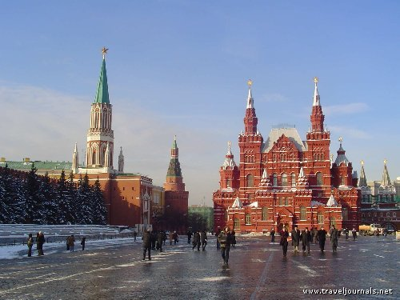
Red Square is a dramatic open cobbled space in the centre of Moscow, originally the city’s market maket place that served as public gathering place to celebreat festivals, listing to government announcements or witnessing executions. The soviet stat turned it nito a memorial cemetery, and constructed Lenin’s Mausoleum to one side and the Resurrection Gate and the capel on the other
and has some of the major tourist attractions like
Lenin’s Mausoleum- Lenin’s Tomb, or better known as Lenin’s Mausoleum, is situated in Red Square in Moscow, and is where Vladimir Lenin’s body can now be found. Since his death in 1924, Vladimir’s body has been embalmed and kept for display. The Moscow Manège is a truly remarkable building situated right next to Manège Square. The square, which was cleared in the 1930s, takes its name from the Manège and is situated adjacent to Red Square. Many visitors are surprised to learn that a manège is an indoor riding academy – especially since few today would guess that this was the original use of this vast building.

St.Basils cathedral
Moscow is also well known as the site of the Saint Basil's Cathedral, with its elegant onion domes. The Patriarch of Moscow, whose residence is the Danilov Monastery, serves as the head of the Russian Orthodox Church. Nothing says "Russia" quite like Saint Basil's, especially at night when the cupola topped towers are floodlit. Quintessentially identified with Russia and Orthodoxy, Saint Basil's Cathedral has recently undergone restoration and now appears much as it must have done when first inaugurated.
With its multi-coloured onion shaped domes and small crowded chapels, the cathedral hardly resembles those of Western Europe. It was built by Ivan the Terrible in 1555-61 to celebrate his campaigns against the Mongols, and famously he was said to have ordered the architect's eyes put out after the cathedral was designed in order that he might never design anything so great again. Whether true or not, it's a grim story for a beautiful building. The distinctively Russian artistry and iconography inside make Saint Basil's a highlight. It is named after Basil the Blessed, the "holy fool" whose remains lie within the cathedral's crypt.
Opening Hours: Wed-Mon 10h00-17h00. Closed first Mon of the month. Tel: +7 (8)495-298-3304.

Kremlin
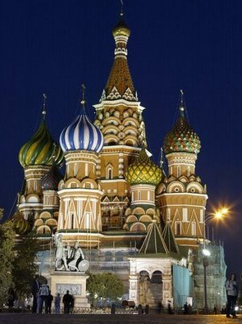
Just a few footsteps away from Red Square lies the heart of Russia. The old Moscow fortress, or Kremlin, is a huge complex with a vast array of attractions.
Originally built in the 1150s it has undergone many changes in the 850-odd years it has stood here. The curtain walls that surround the citadel were only added in the Middle Ages, and the churches that once stood here were demolished in the 15th century to allow the building of the current citadel. There are several cathedrals containing many of Russia's sacred treasures, most notable among them being the Cathedral of the Assumption with its fabulous paintings and frescoes, and magnificent iconostasis.
The State Armoury contains the wealth of the tsars, including the crown jewels used at the royal coronations. The priceless collections include the State Diamond Treasury (accessible via a separate entrance) and exhibits range from court clothes to the royal carriages. There is a magnificent display of the unique eggs sculpted by Fabergé.
You should also take time to visit the sumptuously named Faceted Palace, and its magnificent vaulted main hall and famous "Red Staircase". Facing the palace across the square is the Ivan the Great Bell Tower. At the foot of the tower is the 200-tonne Tsar Bell - the largest bell in the world. It was never rung as during a fire at the Kremlin in 1737 water was poured over the bell as it lay still hot in its casting bed, causing an 11-tonne section to crack off. The Tsar Cannon is a similarly magnificent piece of cast-metal engineering. Dating from the late 16th century it weighs over 40 tonnes and sits in its own square at the northern end of the bell tower.
Some areas of the Kremlin compound are obviously off-limits, but there is still plenty to see within the imposing walls. Make sure that you stay strictly within the marked tourist areas, although the patrolling policemen will warn you if you are wandering off the beaten path. You should allow at least half a day to see even a portion of the citadel and should really make a couple of trips if you want to see everything on show here without exhausting yourself.
Citadel open: daily 10h00-17h00 (closed Thursdays). Visitors wearing shorts are not admitted.
Any visit to Moscow is incomplete without a visit to Ulitsa Arbat. Not far from the Kremlin, this 1.5km pedestrian street is lined by pastel coloured houses that evoke a different, softer time in Russia's history.
Arbat
The Arbat has many quaint sidewalk cafés, street vendors, actors, and artists. The former home of many underground poets and writers during the Soviet era, the Arbat still has a vague aura of rebellion to it. It is one of Moscow's best sights during the long summer days when Muscovites and tourists sit at pavement cafés watching the crowds throng past.
Tretyakov Galleries
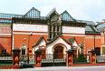
South of the Moscow River from the Kremlin stands the tsar of all Russian art museums. There is no better collection of Russian art on earth than the one to be found in the Tretyakov. Housing the world's greatest collection of Russian Icons, masterful Peredvizhniki paintings, and other pre-revolutionary art, the Tretyakov galleries are easily the equal of any continental museum. The cornerstone of the collection was a present to the city of Moscow from merchant Pavel Tretyakov in 1892. Since then the collection has grown and now includes pieces from the 20th century. Some of the later pieces are now housed in the New Tretyakov Gallery to the south-west of the original gallery, near Gorky Park. Opening hours: Tue-Sun 10h00-19h30. Tel: +7 (8)495-230-7788.
Graveyard of Fallen Monuments
Behind the New Tretyakov Gallery is the Graveyard of Fallen Monuments. It is here that all the deposed statues of Communist heroes have been deposited. It is a magnificent, if weathered, and slightly odd collection of Soviet statuary that tells the tale of modern Russian history.
As you might expect you'll find plenty of Stalins, Lenins, Dzerzhinskiis and Brezhnevs adorning this interesting park along with less recognisable figures, chiefs of police and more minor politicians among them. It's a quirky attraction that provides plenty of photo opportunities and a delightful visit in the unlikely event that you're nostalgic for the Cold War era. From the "Graveyard" you'll easily be able to see the massive and controversial statue of Peter the Great, in visionary posture. Designed by sculptor Zurab Tsereteli it was erected in the late '90s against strong opposition. Tsar Peter still hasn't been forgiven for moving the capital from Moscow to St Petersburg during his reign.
Pushkin Museum of Fine Arts
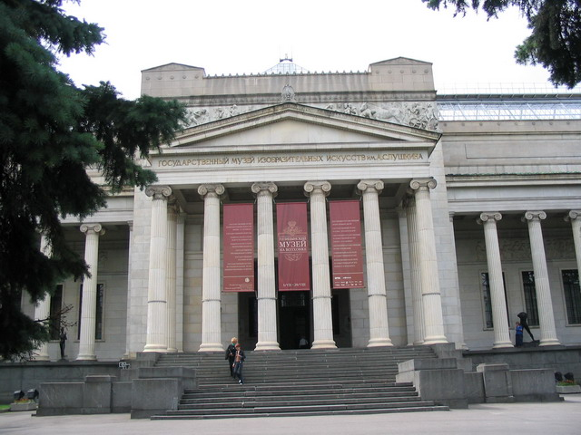 Not far from the Kremlin and Red Square is the Pushkin Museum of Fine Arts, Moscow's premier foreign arts museum which houses many of the most famous Impressionist and post-Impressionist artworks in the world. It also boasts an excellent array of statuary, and post-Renaissance European art.
The original collection was comprised of the private collections of citizens, which were nationalised after the Russian Revolution, but it has since grown, most significantly with the addition of hundreds of pieces seized from the Germans following World War Two. Famously Russia only admitted to possessing these spoils in 1995, and in the face of international consternation the Russian Duma promptly had the works declared the property of the State. Thus swelled, the current collection can boast significant works from the likes of Monet, Picasso, Matisse and Cezanne, spanning several periods of European art. There are also exhibits of religious iconography and an interesting collection of ancient art and artefacts drawn from all over the world.
Ulitsa Volhonka.
Opening hours: daily 10h00-19h00.Tel: +7 (8)495-203-9578/7998.
Novodevichy Convent
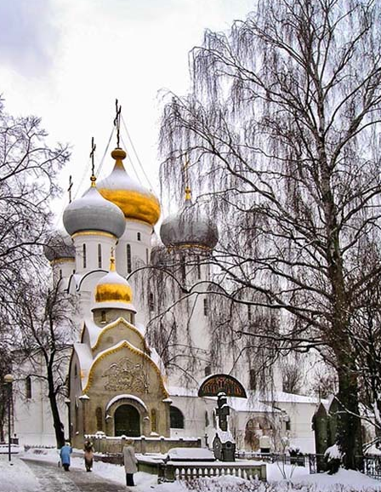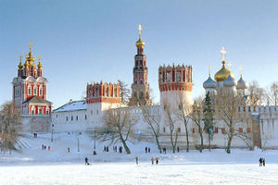
Novodevichy is best known as the home of Peter the Great's deposed half-sister, Sofia. Not wanting to give up the throne to the Tsar after his reaching adulthood, he had her sent packing here in 1689.
The convent was founded in 1524 to celebrate the seizure of Smolensk from the Lithuanians, and was built on the banks of the Moscow River. Its location is significant in that at the site is the place where the Icon of the Mother of God (thought to have been painted by St Luke) was returned to the city following its being briefly removed by the Tsar. Only the Cathedral of the Virgin of Smolensk survives from the original site - the rest of the complex was built by Sofia during her brief occupation of the throne.
Designed to resemble the Kremlin in many ways this was once one of the richest convents in the land and is surrounded by forbidding towered walls. Napoleon is said to have tried to blow the convent up in his ill-fated 1812 invasion of Russia, but (like so much else in that campaign) he failed. The cemetery on the grounds is one of the most prestigious resting places in the country for Russian heroes.
Convent open: daily 10h00-17h30 (closed Tuesdays).

Kitay Gorod
The narrow alleyways and streets to the east of Red Square are called Kitay Gorod, which means "China Town". It is one of the oldest parts of Moscow and well worth a visit.
Wandering its streets you will find the old Moscow Stock Exchange, the Printing House (where Russia's first book was printed), Chambers in the Zaryadie Museum (dedicated to the lives of the Romanov family before they became tsars, emperors and empresses) and the English House (home of the first English emissaries to Russia sent by Elizabeth I).

State History Museum
Located at the northern end of Red Square, the State History Museum houses a rich collection covering the history of Russia from the Stone Age to the present.
Here the grand scope of Russia's tragic history unfolds through over four million artefacts. The archaeological section is particularly extensive, but there are significant collections of artworks and written materials that trace the artistic development of the country over more recent centuries. Currently in the process of renovation, the interior of the building is also worth seeing.
Location: 1/2 Red Square. Tel: +7 (8)495-292-3731. Open: daily 10h00-18h00 (closed Tuesdays).

Bolshoi Opera and Ballet theatre

Moscow’s oldest theatre, the Bolshoi date from 1824 and is Russia’s most famous theatre, with its world-renowed opera and balet companies in residence.
There is only one place for ballet in Moscow and that's the world-famous Bolshoi. Rumour had it once that tickets to the Bolshoi could be had for the equivalent of USD0.50 after the Soviet Union collapsed. Prices have increased, but still won't break the bank, especially for one of the world's best ballet companies.
Book tickets well in advance. Tel: +7 (8)495-250-7317 from 10h00-18h00.
Nearest metro: Okhotny Ryad or Teatralnaya.

Kropotkinskaya
The structure was originally built and used as a traditional manège where horsemen could parade their skills. It also served as a training school for officers. Amazingly enough, the Moscow Manège was large enough to hold all two-thousand soldiers of a standard infantry regiment, as well as an audience. However the manège has long since ceased to be used for horses. In 1831 it was converted into an exhibition place and despite a short stint as an art gallery, this is still its main purpose. The Moscow Manège is a truly remarkable building situated right next to Manège Square. The square, which was cleared in the 1930s, takes its name from the Manège and is situated adjacent to Red Square. Many visitors are surprised to learn that a manège is an indoor riding academy – especially since few today would guess that this was the original use of this vast building.

Cathedral of Christ the Saviour

The Cathedral of Christ the Saviour stands proudly in Moscow today, as the largest church in Russia, and its enormous structure and golden domes can be seen from anywhere in Moscow. This cathedral has fought its way through centuries and was almost lost to the world completely, had it not been rebuilt in the 1990s. Thankfully, Moscow Major, Yuri Luzhkov, did not let the protests of some Muscovites deter him from completing the Cathedral of Christ the Saviour, as many Muscovites accused Luzhkov of trying to leave his mark on the city, and that the replica lacked elegance and proportion. But to most Russians, the reconstruction of this cathedral evoked emotions of patriotism, by seeing a historical landmark rise again.

Ekaterinburg Zoo
It was only in 1994 that the Zoo was reconstructed and there was active finance to revive it. On January 1, 2000 the number of animals housed with in the Ekaterinburg Zoo was approximately 528, of which there were 180 different species. Now, there are more then 240 species of animals, of which 64 are mammals, 90 birds, 53 reptiles, 8 amphibians and 27 different types of fish so the collection continues to enlarge. The Zoo has three pavilions, which are much appreciated by the heat-loving animals not indigenous to the country. One is for the birds and unusual predators, one is for the apes and monkeys and lastly there is one in the Exoterrarium building.
In this three-storey building there are two floors exclusively for exotic animals and the other is the educational centre and junior natural history study group. Visitors can observe two different species of the lemur and galago family, as well as a variety of small apes, for instance Fossas, marmosets and mongooses. The North animals, like the North predators birds of prey, Amur tigers and bears live in the outside cages.
There are 40 species of animals that the Ekaterinburg Zoo houses that are included in the International Red Book, Red book of Russia and Red book of the Middle Ural. Among them are the snow leopards, Amur tigers, agouti, fossas, chimpanzees, erne, lion-tailed macaques, demoiselles, Cuban crocodile, salmon-crested cockatoos, black tailed python and the spur turtle.
Poklonnaja Mountain
The name Great Patriotic War was given by the Russians to describe the war that started in 1941 and ended in 1945, otherwise known as World War II. While the Nazi’s fought on many fronts, the Russian states made up the Eastern Front of World War II. The Great Patriotic War took the lives of 25 million, and the Soviet army was involved in six major battles and approximately 40 offensives. Their effort and dedication assisted greatly in defeating the enemy and bringing the Nazi regime to its knees. Many monuments such as Poklonnaja Mountain pay tribute to the Soviet soldiers that fought the war, and to families that lost their loved ones one the battlefields.
The Stele of the Poklonnaja Mountain stands at a height of 122 meters and is held down by a 25 ton figure of the Goddess of Victory, Nike. She holds a laurel wreath and is flanked by two trumpet sounding Glories. Nike represented Victory in Ancient Greek, and is therefore symbolic to the Soviet victory in the war. Around the granite sign, trees were planted and the area surrounded by the trees was named Victory Park. Within Victory Park is the Central Museum which exhibits approximately 50 000 items of military history, and on Winners Square is a tall obelisk that symbolizes that duration and length of the Patriotic War.
The Poklonnaja Mountain is the most significant memorial that was erected in honor and in memory of the war and countless lives that were lost. Many tourists climb the mountain for its spectacular view point, but visitors should never forget the reason it stands there today

Accommodation in Moscow
Accommodation is expensive in Moscow. Most of the hotels in Moscow are either 5-star international chains or run-down Soviet style outlets. Popular hotel chains are Marriott, Radisson SAS , Holiday Inn etc .
Accommodation in Moscowis divided into two camps. On one hand you will find luxury hotels offering all the facilities you could expect from any capital city in the world. On the other hand are the Soviet era hotels, characteristic but not always up to international standards, although their idiosyncracies will provide plenty of stories for when you return home.
The modern hotels in the city centre often occupy old buildings and are usually foreign chains or foreign owned. Inside they represent the best standards you could expect from hotels anywhere in the world. In the suburbs is where you'll find the Soviet era hotels, usually in large edifices. There are some massive modern complexes as well however, which are dotted on the periphery of the city and are not always ideal for sightseeing. The banks of the Moscow River are a good place to start looking for a hotel. There are some beautiful buildings left over from Soviet times that reflect the grandiose ambitions of that period, and these have now been converted to contain luxurious accommodation

Nightlife
Moscow's nightlife is notorious. The expat and student communities turn the city into a club capital, although don't take quality for granted. There is a surprisingly trendy and innovative underground scene, although a bit of local knowledge is usually required to unlock these secrets. For the rest the scene moves rather quickly and you should check out carefully where you are heading before you pay your way in. Yesterday's hotspot fast becomes a rather desultory affair.
Many clubs offer "exotic" evening entertainment, and it can sometimes be hard to differentiate between those that have some kind of adult floorshow and those that don't before you pay the usually high cover charge for admission. Although the better clubs in the city are usually safe, often prostitutes operate in them, and will target tourists. Some also have a reputation of being hangouts for local gangsters. Keep your wits about you, stay sober and avoid insulting anybody and you should be all right.

Territoria
Tverskaya ulitsa, 5/6
Tel: +7 (8)495-292-4544
Close to the central attractions of the Kremlin and Red Square Territoria is a popular place with students, though its recent refurbishment may soon entice a broader cross-section of clubbers. The music styles are a real mixed bag but tend to be young and pretty upbeat by Moscow standards. Expect anything from acid jazz to heavy drum and bass.
Propaganda
Bolshoi Zlatoustinskii Pereulok, 15
Tel: +7 (8)495-924-5732
Cool club/bar packed with expats and locals most nights of the week, Propaganda is one of the places to be seen. A host of local and foreign DJs play a mix of mainly techno and acid jazz with a sprinkling of house, the warehouse-style décor a sign of its trendy aspirations. There's usually a gay night on Sundays, but check to be sure.
Karma Bar
Pushechnaya ulitsa, 3
Tel: +7 (8)495-924-5633
Attracting a predominantly young crowd, Karma plays mainly R&B, chart and Latin music. Not one of the most fashionable places in town, but an unpretentious crowd gives it a fun vibe, and a packed dancefloor is almost always guaranteed.

Excursions There are several places within striking distance of Moscow that make great day long or half-day excursions.
Sergiyev Posad
70km north-east of the capital is the fortified monastery of Troitsko - Sergieva Lavra, in the town of Sergiyev Posad. It is counted among Russia's most beautiful attractions, and lies in the heart of the "Golden Ring" - a series of towns of great historical note - worth visiting in their own right.
The complex was first established in the 1340's by St Sergius himself. The earliest building extant is the white Trinity Cathedral which dates from the early 1400s. The interior decoration by Rubylov counts among some of the finest religious art from the period still standing in Russia. The monastery itself is still in use and remains closed to visitors, but you should see the other major church in the complex, the multi-domed Cathedral of the Assumption, the catherdral of Trinity as well as the Toy museum,
Sergiev Posad can be reached by bus, train or taxi. The bus which leaves f rom the main train Shcholkovsky Bus Terminal takes about 2 hrs. the train leaves Yaroslavsky Train Station and takes about 1 hr 30 min.

Volga Canal and River Cruise
Moscow doesn't actually lie on the Volga, it is connected to the massive river by a canal. You can still cruise the waterways though and the more minor Moskva River allows a pleasant cruise through the heart of the city.
If you want something more substantial you can take longer cruises down the canal to the major waterways. Away from the city limits you pass through idyllic Russian countryside and can see some of the inner beauty of this fascinating and inaccessible territory. Cruises can range from several hours to several days. If you have a week or more to spend messing about on the river you can travel as far as St Petersburg from the River Station (Rechnoi Vokzal).

Suzdal & Vladmir
Located 200 km from Moscow, Suzdal’s conservative, tranquil beauty complements Vladmir’s grand heritage together they form an ideal trip from Moscow. Suzdal houses a fortress and a collection of riverside convents and monasteries that dates back to the town’s heyday in the 11th to 13 centuries.
Vladmir, oncea provincial capital more prosperous and holy than Moscow, centrs around its incomparable Catherdaral of the Assumption.
To get there: Intercity buses run direct to Vladmir from Moscow’s main Shcholkovsky bus mstation and the trip takes 2 hrs.

Indian Restaurants:

Ali-baba
Address - Prospekt Mira ave, 56

Darbar –
Address: Leninsky ave, 38, Sputnik hotel

ST. PETERSBURG / LENINGRAD

Traditionally a city of artists and intellectuals, with such eminent progenies as Dostoyevsky and Shostakovich, visitors to St Petersburg are in for a cultural orgy. It's difficult to know where to start in this assembly of splendid baroque houses and magnificent cathedrals, Prince Menshikov's Dutch-style Palace vying for attention with the ornate Cathedral on the Spilt Blood and the forbidding Peter and Paul Fortress. St. Petersburg is one of the most beautiful cities in the world. It is often referred to as the Venice of the North or the Paris of the East, but its beauty is really a brand all its own. From the White Nights festival during the mysterious summer twilight to top theater and ballet productions and concerts on magical winter evenings, the city offers a vibrant cultural life that is second to none. Though many tourists visit Moscow rather than the country's second city, an increasing number of foreign visitors are discovering the myriad treasures hidden in this most idiosyncratic of cities, surely a city of dreams if ever there was one.
Getting There

Air : St Petersburg is served by Pulkovo International Airport. The airport has been under an extensive rebuilding programme in recent years. It's now a small but efficient and modern airport.The airport is located about 30 minutes from the city.Cabs are availabs to the city.

Train : Entering St. Perter’s berg by overnight train from Moscow is one of the most romantic things you czn do in Russia.(travel time 7-8 hrs)The Moscow-based trains arrive at, appropriately, Moskovsky (Moscow) Station, right on Nevsky Prospekt, within walking distance of several major hotels. Easy train connection is from Helsinki, 5 1/2 hours away. From Poland, Germany, and the Baltic states, trains arrive at Warsaw Station.The trips end at St. Petrsburg’s Finland station.

Bus : Buses arrive at St. Petersburg Bus Station from Scandinavian countries.

City Layout
The Neva River folds around the city. The city’s main land artery is Nevsky Prospekt, a 4km-long avenue that slices across the city center roughly northwest to southeast.

Getting Around

Public Transport
Buses- The same cannot, unfortunately, be said of the public bus into the centre, which is miserable, overcrowded, and looks like it's celebrating a 300th anniversary of its own. The least-worst option if you refuse to take taxis is the shuttle minibus service (No. 39) which leaves approximately every 20 minutes from 05h30 until the last flight, and connects to Metro Station "Moskovskaya" (17km). Fares change rapidly - currently they stand at RUR15 per person, and then an additional RUR7 for your onward Metro ticket into the city.

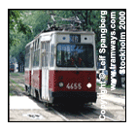
Metro
As far as it runs the Metro is ferociously efficient, with a bargain RUR14 any-distance fare (or a ticket allowing ten journeys over a 7-day period for RUR115), and trains which come every 2-3 minutes without fail.
Don't forget to allow a few minutes at each end merely for the escalator journey - it's very, very deep, because of the waterways above. Avoid rush hour (Mon-Fri 08h00-09h30 and 17h00-19h00), unless you want to understand what Marx's term "the solidarity of the Proletariat standing shoulder-to-shoulder" really means.
Although not as beautiful as the Moscow Metro, some stations (notably Mayakovskaya) are attractions in their own right, in overblown Soviet style.
The Metro operates from 05h45 until midnight. Signage is solely in Russian - learning the 33 letters of the Cyrillic alphabet gives you a substantial advantage when using this mode of transport.
Buses and trams
All the surface forms of transport have a "pay-the-conductor" system on board - the conductor gets very upset if you sit in her seat. Flat-fare tickets are RUR6 per ride (but subject to sudden changes) - having small change will greatly help international relations, whilst presenting a RUR500 bill for the six rouble ride may earn you a free lesson in contemporary colloquial Russian.
A convenient alternative to the public bus are private minibuses, which charge around RUR12-15, depending on the length of your journey, making stops on request only along their route.
Special Warning: During the Summer "Navigation Season" (May-Sep) all city bridges are raised at night to allow ships to pass. Each bridge has its own timings, but you should assume that if your ride home involves a bridge, you need to be clear of it by 01h00 to be sure of getting back. Otherwise you could be waiting four hours until it closes again. There are no car-ferries, alternative routes, or any ways around this! The biggest obstacle is Palace Bridge itself, the main crossing from the mainland to St Basil's Island, which closes at 01h00 sharp, and divides the city into two until 05h00.

Driving public Transport
In a city where taxis are plentiful and cheap, there are almost no advantages to hiring a car. Most Russian men don't take a driving test, as they learn to drive while on compulsory Army Service - learning a uniquely military style of driving they pursue later in civilian life. Since St Petersburg's notoriously pitted roads often resemble a war-games arena, there is a certain kind of logic to this.
If you bring your own car from Europe you will have to make a customs declaration promising to take it out on departure as well as having the vehicle registration and insurance documents handy. It's a virtual impossibility to rent a car in a neighbouring country to get better terms, as crossing the border is almost always a contractual exclusion - similarly, you cannot take your Russian-rented car into Estonia or Finland without a great deal of difficulty.
Points to consider:
• Traffic drives on the right and speed limits are 60km per hour (37mph) in the city, 110km per hour (68mph) in outlying areas and 120km per hour (72mph) on highways.
• The wearing of seatbelts is mandatory. At many junctions it's impossible to turn left and you have to follow a diversion route, which is generally well sign-posted.
• Russian road sign markings are broadly the same as the rest of Europe. Major roads are designated by a letter (such as 'M' for motorway) and a corresponding number.
• One special point to note is that on roundabouts you give way to joining traffic which has priority - the opposite to what you might be used to at home. At DPS road-blocks on inter-city roads you must stop, until you are given the all-clear to proceed. Radar guns are in regular use (especially on the Petersburg-Moscow Highway, and especially near Tver).
• If you are pulled over for any reason, you must halt immediately (you can legally be fired-upon if you fail to do so) - you should get out of the car and present your documents without being asked to do so. Be polite, keep calm, do whatever they tell you. Be ready to apologise, even if you do not agree that you have done what they say. Do not get angry even if excessively provoked with accusations you find unreasonable, and remember - "there is always a way out of this". There is a zero-tolerance law on driving under the influence of alcohol or narcotics, and the penalties are very severe (and there is not a way out of this). It is, on the whole, much better to let a local driver bear the brunt of all this for the small fee it will cost to have them drive you instead (see below).
UMA Autoclub provides a 24-hour breakdown service on St Petersburg's roads (Tel: +7 (8)812-329-5777).
The Traffic Police (officially now called GIBBD or DPS, although you will still hear the old name "GAI" used) are bored and underpaid, and fill their time - and pockets too, sometimes - stopping people for petty offences, or for no reason at all. Bribery is mostly endemic; expect no mercy as a foreigner - indeed, expect to be seen as a wallet on wheels.
If you are still determined to rent after all that, then you will need an International Driving Licence and licence from your home country. The minimum driving age is 18. Major car hire firms can be found at the airport and in the city centre.
The following table provides approximate driving distances between selected cities. Kilometres in the lower left of the table, miles in the upper right.
From  St Petersburg | Kilometres | Miles
Moscow | 713 | 446
Pushkin | 35 | 22
Peterhof | 30 | 19
Lomonosov | 39 | 24
Novgorod | 189 | 118
Kolpino | 33 | 21
Vyborg | 142 | 89
Kronshtadt | 50 | 31
Murmansk | 1345 | 840
Tallinn (Estonia) | 357 | 223
Helsinki (Finland) | 390 | 244

Taxis
There are two kinds of taxi in St Petersburg - official, and unofficial. Probably 90% of the taxi-rides taken in the city fall into the second category, called "chastniki" ("independents"). Official taxis are yellow, clearly marked "Taksi" in Russian, and in theory they operate on a metered fare (but in practice they usually don't). Licensed taxis don't often cruise for fares - they more usually hang around places where they enjoy a monopoly on business, like train stations, airports, nightclubs and hotels. This isn't exactly a "legal" monopoly - it is maintained by chasing away any competitors.
The hiring process consists of you opening the passenger door (don't wait for the window to come down - it never will), and stating your destination. The response is usually "how much?" from the driver, forcing you to suggest a figure. (Suggestion - do not hold onto the door-handle if you plan under-guessing by large amounts, as it's surprising how quickly those old taxis can move off.) As a general rule, figure on offering RUR100 for each ten minutes of expected driving (this is actually rather generous, you could even try lower), and bargain only in units of RUR50. However, there is almost no bargaining if you fail to name a price he'll consider - he will drive off straight away without offering you a chance to up your offer.
You can try insisting that he goes on the meter, but most taxi drivers refuse to do so. Fares rise after the Metro closes at midnight, or in the rain, or if the local soccer team lost. Look around you - if you're outside a grand hotel, a theatre or nightclub, or something similar, try walking 200m down the street, and fares will drop like magic. Assuming you eventually reach agreement, on arrival you pay strictly what was agreed and not a kopek more - you never, ever, tip taxi drivers in Russia (nor do they expect it, unless they have helped you with heavy baggage up many flights of stairs).
The procedure with unofficial taxis is basically the same, but you can offer approximately half the fare you'd offer an official taxi, with a good chance they will take it. People inevitably wonder how safe it is to climb into a car with a complete stranger and here you have to let experience be your guide, but there are still some watchwords.
Never get into a car if there is anyone else other than the driver already in it. Do not allow the driver to pick up other fares along the way, and if he does so anyhow, get out. If you have a bad feeling, glance behind the driver's seat to check there is no-one hiding there. However, bear in mind that taking "unofficial" taxis is the norm rather than the exception, and that if anyone did want to rob you, stealing an official taxi would be far less risky than using his own car (which could be traced) to do so.
The "unofficials" are a strange mixture of people ranging from those who just hope to share petrol costs on a journey they are making anyhow, people doing it for a living, official chauffeurs moonlighting with the car while their boss is away, or even just lonely people looking for a chat. In a city of intellectuals, they are actually a feature of the city, and it can even be a pleasure to ride with them whilst they tell you about their life, or even read you their poetry. With "unofficial" taxis, you should scale the price you offer according to the vehicle - lower for a pensioner in his old Moskvich, more for the pro chauffeur offering to ferry you for pennies in a Mercedes. And again, no need to tip.
Must sees

Winter Palace & Hermitage

The magnificient green, white and gold Winter Palace is superbly sutuated on the banks of the Neva River, a Russian Baroque building that is the biggest and the most lavishly decorated palace in the city. The Hermitage Museum is one of the world’s greatest art museums that has grown from a small collection of paintings started by Catherine the Great in 1764, to a massive display of over 3 million exhibits! The gargantuan Victory Column in the centre of the square commemorates the famous 1812 campaign against Napoleon Bonaparte.
Of Peter's own palace - in this city of palaces - there is no visible sign. Its structure lies within the expanded, redesigned and reinvented Winter Palace, commissioned by a young German princess named Sophie of Anhalt-Zerbst. The scope of the Hermitage Collection defies all superlatives, and even the averagely-interested may want to consider multiple planned visits to make even modest headway with it all.
Public access for individual visitors is from Dvortsovaya Naberezhnaya (Palace Embankment) 34. Tel: +7 (8)812-571-8446.Opening hours : Tue-Sun 10h30-18h00. Extended opening in summer.

Prince Menshikov's Palace
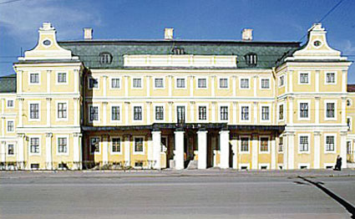
Peter the Great's formative role went far beyond merely commissioning the work on his city; he even sat down and mapped out the street-plan and canal network himself, together with his inseparable drinking companion Prince Menshikov. Determined to drag Russia directly from the 15th into the 18th century, the pair plotted that all "backward" Russian traditions (including even beards) would be abandoned in favour of the latest modes they had seen in Europe.
Prince Menshikov's Palace is a shining first example of the philosophy - built entirely in Dutch style, elegantly restrained, and decorated with imported Delft porcelain. Moreover, it made the clear point that all noble families in the country were now expected to lavish equal amounts on palaces in the new capital. (It only became apparent later that Menshikov had stolen the entire cost of his new home from the State coffers.)
Universitetskaya Naberezhnaya 15. Open: Tue-Sat 10h30-18h00; 10h30-17h00. Admission: RUR350 and RUR300 for guided trip around Museum. Tel: +7 (8)812-571-3465.

The Kunstkamera of Peter

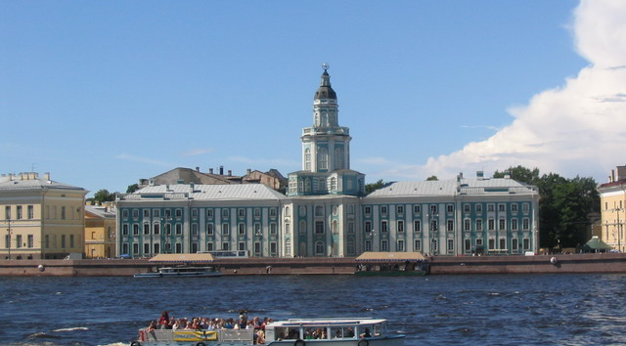
Whilst on St Basil's Island (the city is composed of 22 major islands and numerous smaller ones, although modern asphalting conceals many of the gaps from visitors) those of strong disposition shouldn't miss The Kunstkamera of Peter I.
This ghastly assortment of Nature's aberrations - deformed human embryos, two-headed dogs, and other "monstrosities" - was Peter's private Collection of Curiosities. Newly-arrived official visitors to his city were taken on conducted tours - to test their nerve. Universitetskaya Naberezhnaya 3. Open: Tue-Sun 11h00-17h45 (closed the last Tue of each month). Admission: RUR200. Tel: +7 (8)812-328-1412.
The collection later fell under the care of the adjacent Zoological Museum, which numbers one astounding exhibit amid numerous dusty cases of stuffed penguins: the Siberian mammoths unearthed whole from the permafrost of the Lena River, complete with flesh, some fur, and a few mammoth droppings for good measure. Universitetskaya Naberezhnaya 1. Open: daily 11h00-17h00. Admission: RUR200. Tel: +7 (8)812-328-0112.

Canal Boat Ride
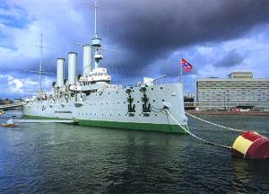

Peter the Great's original concept for the city was that it should be built on a network of canals - rather than muddy and rutted 18th-century roads - like his beloved Amsterdam (the nickname "Northern Venice" is rather misplaced).
A canal-boat ride is almost obligatory, if only because many of the grand buildings were built showing their fairest face to the waterside visitor. There are numerous operators, and prices and politeness don't always go hand-in-hand (nor do any of them offer a commentary in anything other than Russian). The friendliest service is from "The Old Galleon" (which is the staging-post, not the vessel by which you travel) at the Anichkov Bridge; service-with-a-snarl (and at higher prices) is dispensed by the competition on the other side of the bridge.
The nicest route and best-value price is on more modest craft departing from the intersection of the Moika River with Nevsky Prospekt. None offer refreshments on the 1.5/2-hour trips, so take your own, plus some sun-cream and a hat. Prices go from RUR150 per person depending on the greed of the operators (who tell tall tales explaining why foreigners are charged treble-price to hear a commentary they can't understand).
USD80+ may rent you a small motorboat and captain of your own (you need a licence, so no self-hire) if you ask at The Old Galleon in advance, but bear in mind that only larger craft can safely navigate the Neva River itself.
Navigation season: approx. May-Sep (ice-floes may prevent safe sailing at other times).

The State Russian Museum

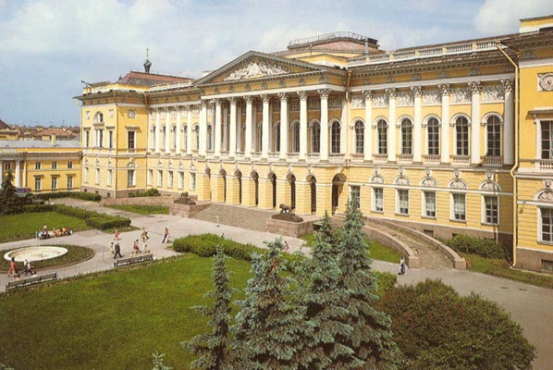

Whilst the Hermitage is almost exclusively devoted to Western art, the State Russian Museum is the repository of Russian Old Masters, a body of work that rarely tours abroad, making it necessary to catch this national treasure while you can. Although the output of Vrubel, Aivazovsky, Venetsianov and others is barely known outside Russia, this is a stupendous collection, most especially because of the rich trove of work by the supreme portraitist of the late 19th and early 20th century, Repin. His giant canvas "The State Parliament" shows a troubled Nicholas II among his Ministers, only a short time before all would find themselves exiled, imprisoned or executed. Aivazovsky is known as the Russian Turner - the eye trembles at the boiling seascape of "Seventh Wave" before even noticing the tiny liferaft of the doomed sailors. Like the Hermitage, the majority of this collection is displayed in a former palace, Mikhailovsky, the work of Italian architect Rossi, but unlike the Hermitage, the Russian Museum was opened as the first public art gallery in the 19th century.Further works belonging to the State Russian Museum are displayed in nearby Stroganov Palace, Marble Palace and St Michael's Castle.
Mikhailovsky Palace, Inzhenernaya str 4. Open: Wed-Sun 10h00-17h00; Mon 10h00-16h00.(Last admission an hour before closing). Admission: RUR300, adults; RUR150, children. Tel: +7 (8)812-595-4248.

The Cathedral on the Spilt Blood
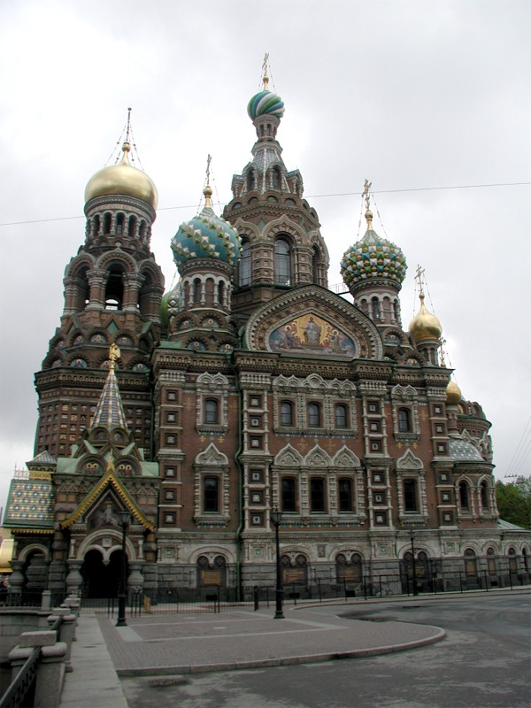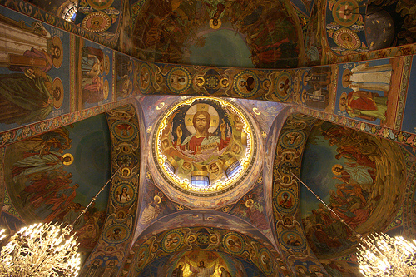
The Cathedral on the Spilt Blood commemorates the spot where the progressive and reforming Tsar Alexander II was blown to pieces by anarchists dissatisfied with slow progress. His son Alexander III set a police state in motion to stamp out every trace of liberalism and anarchy in Russia, thus mobilising the anti-government forces who would eventually dislodge and murder his own heir Nicholas II.
Alexander III also built this extraordinary cathedral, abandoning European fashions in favour of a mythical "golden age" of backward-looking and somewhat hokum Russian traditions, including the multi-coloured domes in imitation of St Basil's in Moscow. In fact, all the things his poor old father - whose Blood had been Spilt - passionately hated.
Spas-na-Krovi, Naberezhnaya Canala Griboedova 26. Open: Thu-Tue 10h00-19h00. Admission: RUR350. Tel: +7 (8)812-315-1636.

The Peter & Paul Fortress
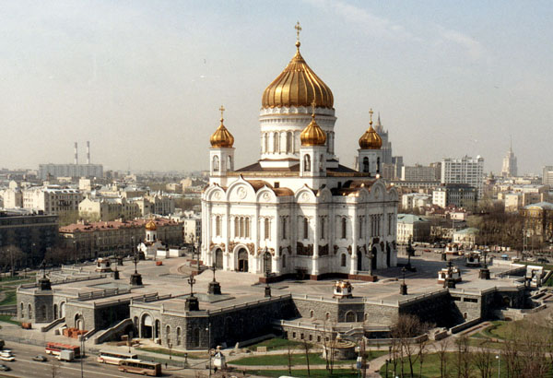
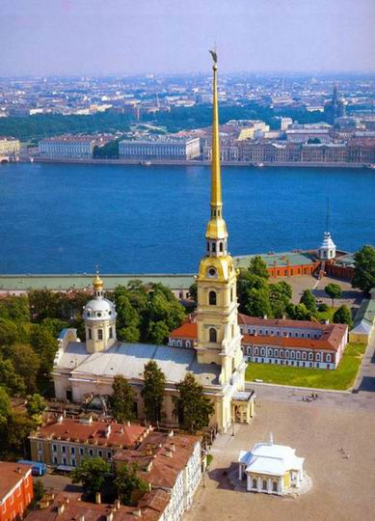

Built as a riverhead garrison to prevent further Swedish incursions into Russian territory (the Swedes had invaded by simply sailing down the unprotected rivers), the Peter & Paul Fortress is the earliest and oldest stone construction in the city (dating from 1703).
Soon supplanted by an even larger naval facility upriver at Kronstadt, the forbidding walls (20m thickness of solid stone blocks all round) found a new and better use: for keeping people in, rather than out. It functioned as the Maximum Security Prison of Imperial Russia until the 1917 October Revolution closed it down Bastille-fashion. Unwilling guests here included the author Fyodor Dostoyevsky (lucky enough to have friends at Court to commute his death-sentence to Siberian exile) and Lenin's older brother - who had no such connections, or indeed luck.
Only steps away from the festering cells is the final resting place of the Romanov Tsars (from Peter the Great onwards), the garrison's Cathedral of Peter & Paul designed by the Italian architect Trezzini. In 1998 the (alleged) remains of the last Tsar Nicholas II and his family were transferred from Ekaterinburg - where all had been murdered in 1918 - and joined the bones of their regal ancestors here. The fate of Princess Anastasia has prompted much discussion, a top-selling animated movie and at least one false pretender, but here she lies (according, at least, to the commemorative stone marking the grave).
Petropavlovskaya Krepost, Zayachii Ostrov Island. Open: Tue, 11h00-16h00; Thu-Mon 11h00-17h00. Admission to the fortress grounds is free; a ticket to visit all eight monuments within the fortress costs RUR120. Tel: +7 (8)812-238-4550.

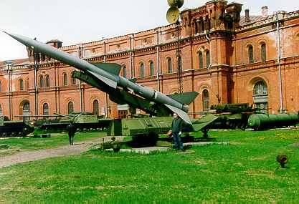
Militry-historical museum of artillery, engineers and signal corps

The world's largest military museum, it was founded in 1703. Located in the building of the old Arsenal. The collection of the museum contains 750 000 items: examples of weapons, military uniforms and equipment, banners, orders, battle relics of the Russian Army. This museum is located just across a narrow canal from the Peter and Paul Fortress. It is a great place to visit with your kids: they will particularly enjoy the open air exhibition of artillery and missile launchers in the museum's yard.
There are also temporary exhibitions, a nice little shop stocked with models of weapons and miniature soldiers and a cafe.
Open: 11.00 - 17.00
Closed on Monday, Tuesday and the last Thursday of the month.

The Yusupov Palace
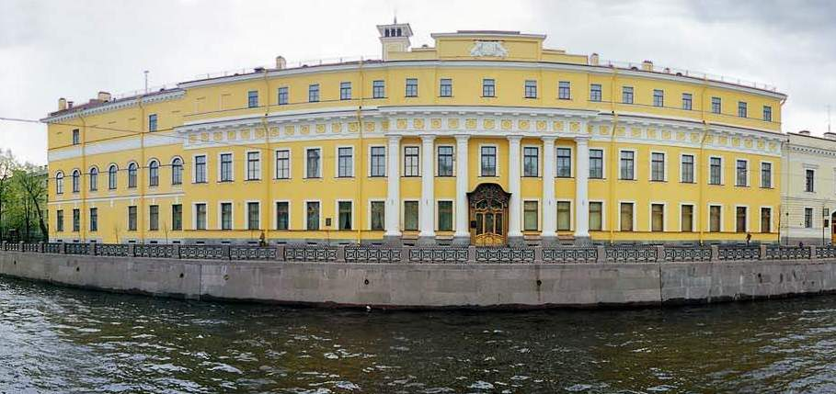

Count Yusupov and his family were - according to popular rumour - richer than even the Tsars themselves. This is a rumour we must accept on trust, since the Yusupov Palace was so thoroughly ransacked by the Bolsheviks in 1917 that nothing remains except the bare rooms - and the Private Theatre.

Nevsky Prospect

Almost 5 km long, Nevsky prospect is one of the best known streets n Russi and is the main thoroughfare of St. Petersburg, starting at the Admiralty whose glided spire is a famous city landmark, to the Moscow Railway station and then to alexandr Nevskyu Monastry where some of the country’s most celebrated artistic figures are buried.

St. Isaac cathedral

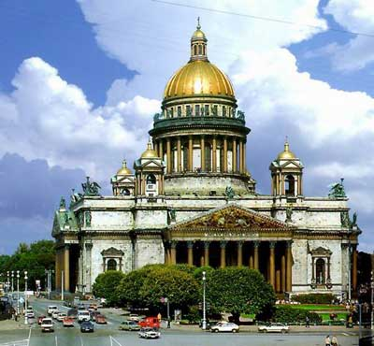

The golden dome of St. Isaac’s Cathedral dominates the skyline of St. Petersburg, the colonnade around the cupola offering superb panoramic views of the city. The Russian Classic style exterior encloses a splendid interior adorned with red granite coloumns, exquisite mosaics, painted ceilings, sculptures, frescoes and a beautiful stained glass window.

Excursions

Peterhof
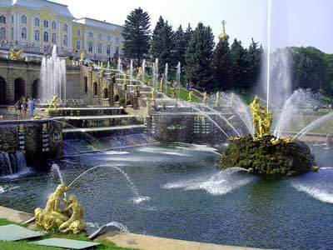
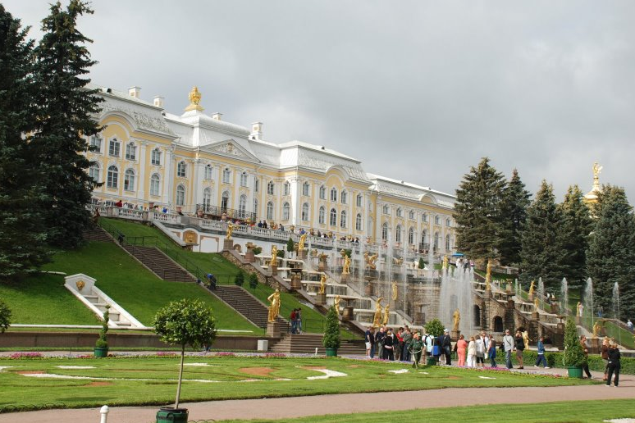
Peterhof, just 30km west of the city centre. If you only have time to visit one place outside central St Petersburg, make sure of going to the stunning palace and garden complex .
Built by Peter the Great as a summer residence in the early-18th century, this opulent mini-city incorporates several palaces, grottoes, parks and, most famously, fabulous fountains cascading throughout the grounds' numerous ornamental gardens. Top architects of the time from all over Europe collaborated to create this grandiose affair and at one point more than 5,000 people were working on the project simultaneously.
The result, needless to say, was a magnificent display of the Imperial splendour that Peter no doubt wished to portray. Modern day visitors can easily spend a whole day exploring the Great Palace, along with the smaller palaces and outlying buildings. It's best to choose a fine day to visit, though so that you can wander around the stunning gardens, which really are the highlight of any visit here. This is a favourite weekend retreat for St Petersburg who come for long walks to admire the fruit garden, flower displays, statues and fine topiaries - and, of course, the fountains.
To get there, the "Meteor" hydrofoil - summer only - costs RUR200 per person each direction, ticket gives free admission into the grounds (but not the Palace) on arrival. The timetable is chalked-up at the pier. Other times of year, or as an alternative to the hydrofoil, the bus from Baltyiskaya Vokzal (look for the double-decker marked "Peterhof") and takes approx. 40 minutes. Buses back into town can be chaotic and overcrowded at the end of long summer days, and there is no timetable.
Alternatively, a rail service operates to/from the station "Novy Petergof", which is a long walk, or a short bus ride (Bus 350/351) from the palace. These trains are currently operating from Varshavsky Station in St Petersburg, relocated from Baltiysky Station during rebuilding. This situation is open to change without much notice.
Open: Tue-Sun 10h30-18h00. Closed Mon and last Tue of the month. Parts of the complex are closed in winter. Tel: +7 (8)812-427-9223

Pushkin (Tsarskoye Selo)
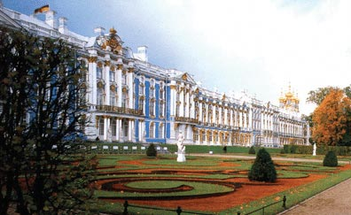
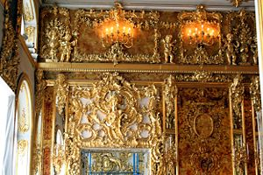

Another favourite daytrip from St Petersburg, Pushkin, like Peterhof, is home to a beautiful 18th-century palace and gardens as well as a number of attractive churches and a lively carnival every June.
A small town about 35km south of St Petersburg, Tsarskoye Selo, or the "Tsar's Village", was Catherine the Great's favourite summer retreat.The world famous amber room – gutted by the Nazis are recently meticulously constructed- is a major draw at Catherine’s Palace. It was she who developed the palace and gardens to their full glory, replacing the baroque style in which they were originally built in favour of an elegant but slightly less over-the-top form of decor.
The main Catherine Palace and its surrounding pavilions and manicured gardens make an ideal escape from the city, and the town itself also warrants a wander round. Only a few miles from here is yet another palace and park at Pavlovsk, which could be combined with a visit to Pushkin, or is a possible alternative destination. Regular train and bus services run to Pushkin from St Petersburg.

Kronstadt
Lying 29km north-west of St Petersburg, the small island of Kotlin is home to the town of Kronstadt, with its heavy fortifications built up by Peter the Great.
Founded in 1723, Peter developed the island fortress along with St Petersburg and there is a wealth of architecture from the period here, including some attractive churches of various denominations (to cater to the disparate populations that have lived here over the years) as well as many of the original fortifications.

Vyborg
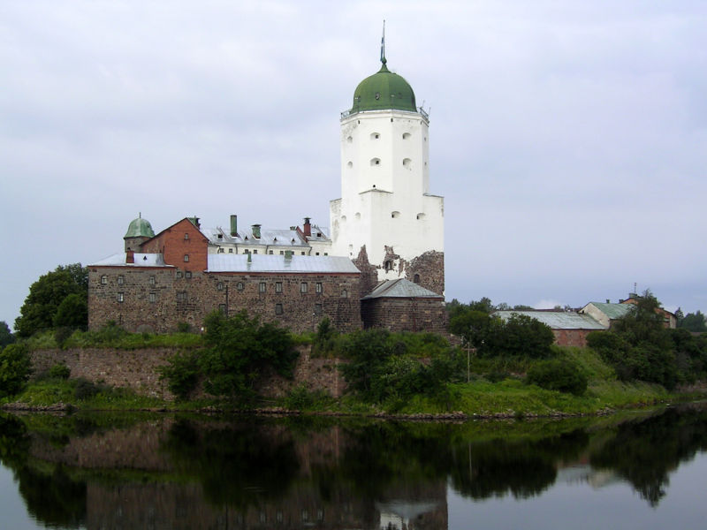
For a journey into an entirely different era and mindset from St. Petersburg and the imperial estates on its outskirts, head to Vyborg. This 13th century, cobble stoned city near the Finnish border has less glamour but more depth than Peter the Great’s capital. Trains also run 3 times a day from St. Petersburg’s Finland’s Vokzal Station; the trip takes 2 hrs one way. Key sights are Vyborg Castle, the Old Vyborg district and the Market Square.
Indian Restaurants:
Tandoori Nights
Address:Voznesdensky pr. 4

